4.Product Introduction

4.1 UI Design

4.1.1 OptAdvisor Home Page

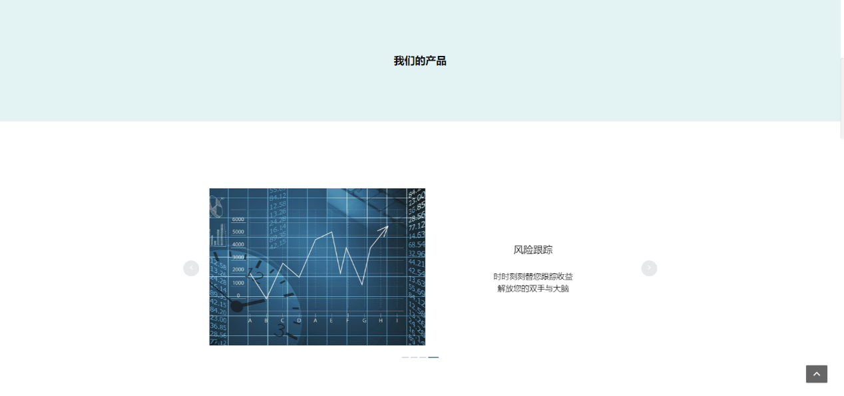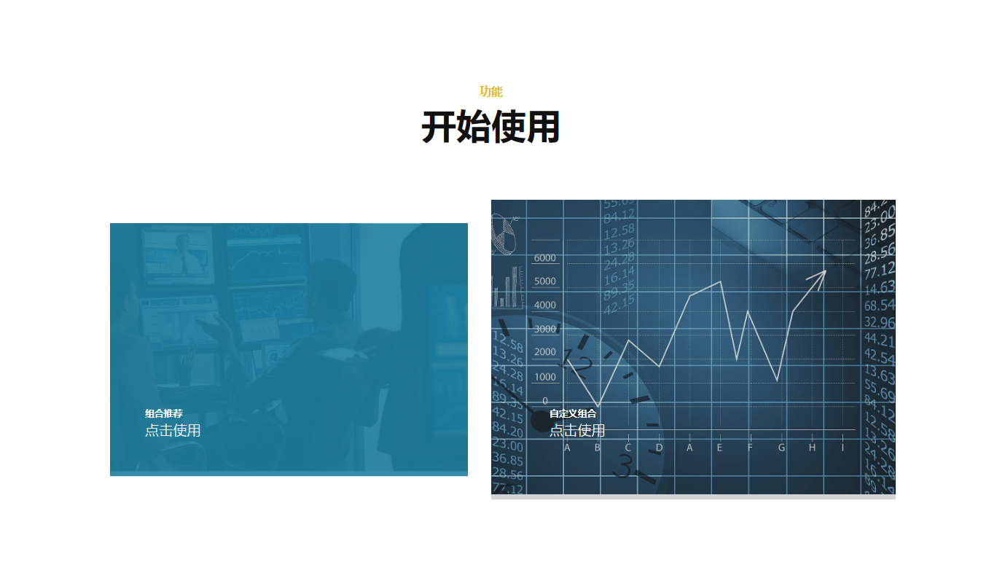

The home page mainly displays major functions and features of this investment consultation system. Users can click Learn More or scroll mouse to view product-introduction pictures; click Login or Register button and then skip to related pages; users can click Portfolio Recommendation when you are on to enter Allocation Page, click DIY button to enter DIY page, and click Browse the Market to enter 50ETF page.

4.1.2 Register

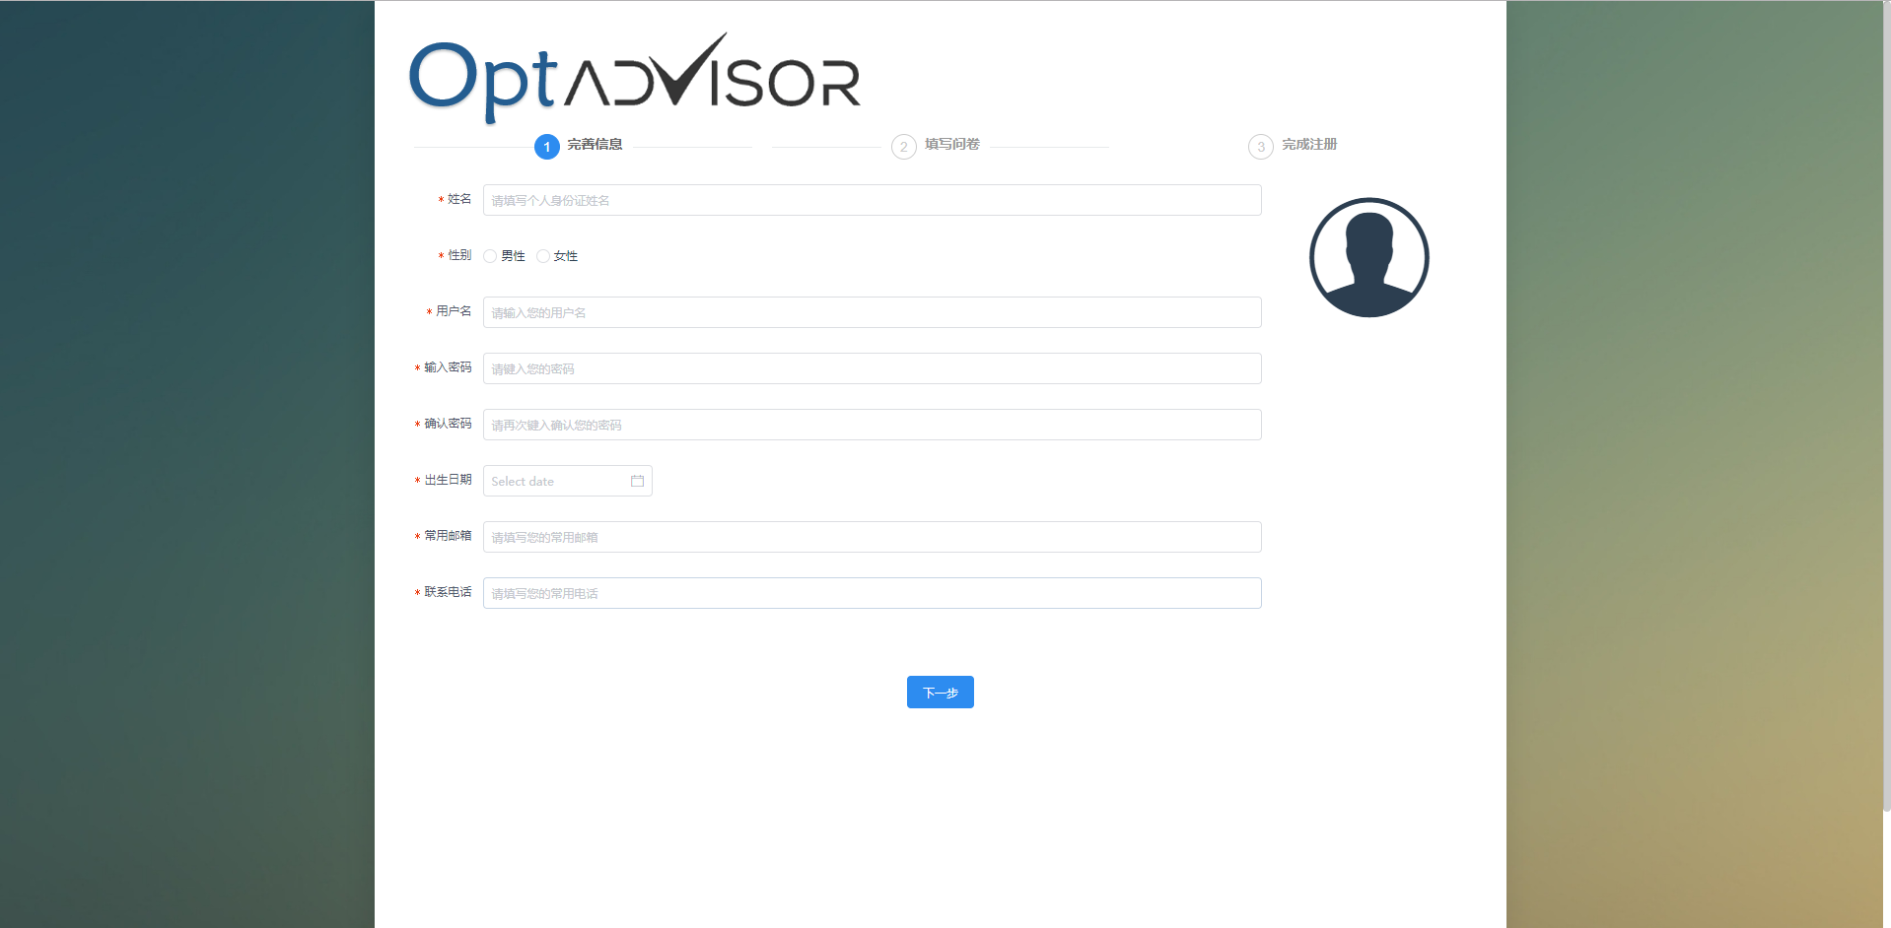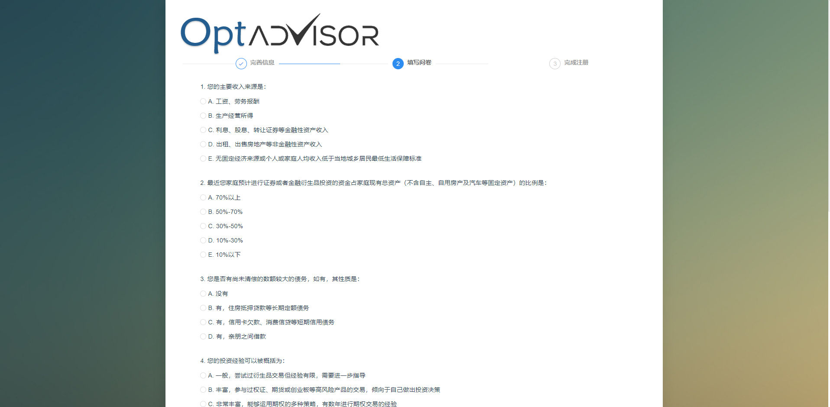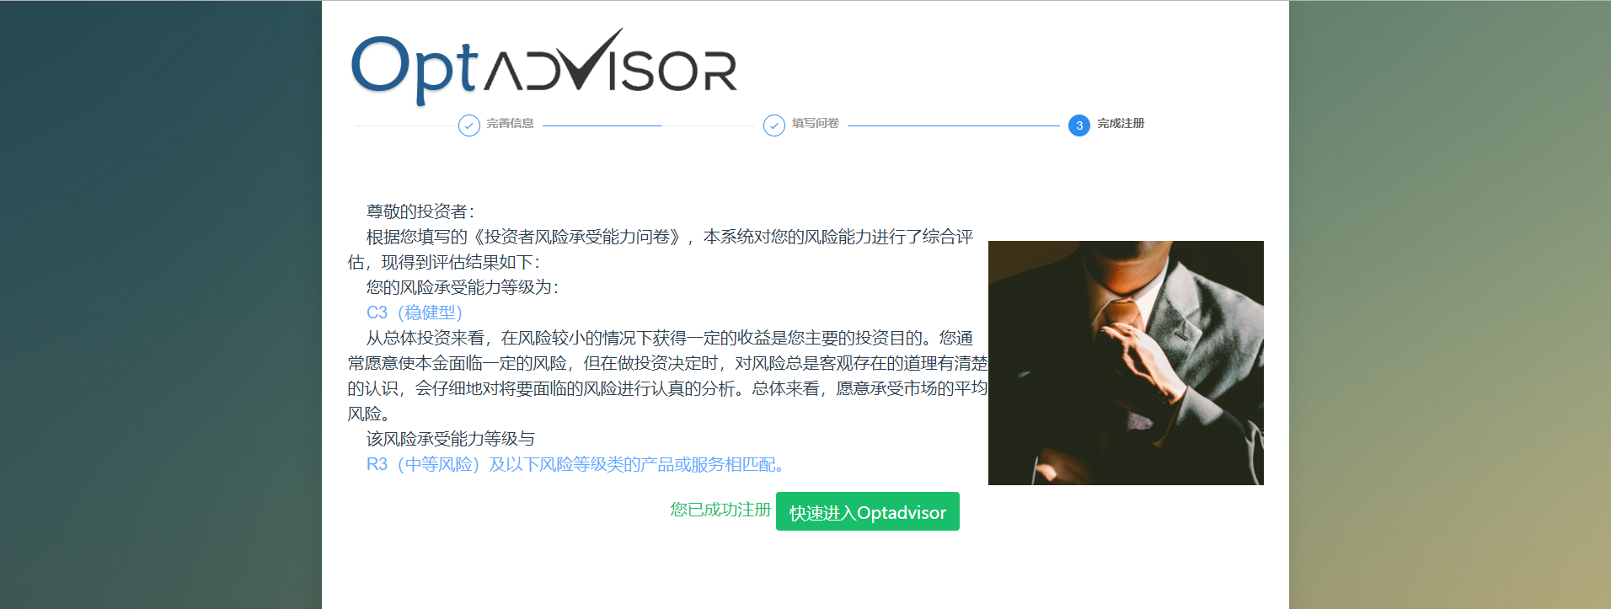

Fill in personal information and questionnaire first, the system will calculate risk evaluating results according to users’ own preferences, which will provide users better recommendations.

4.1.3 Login and Change Password

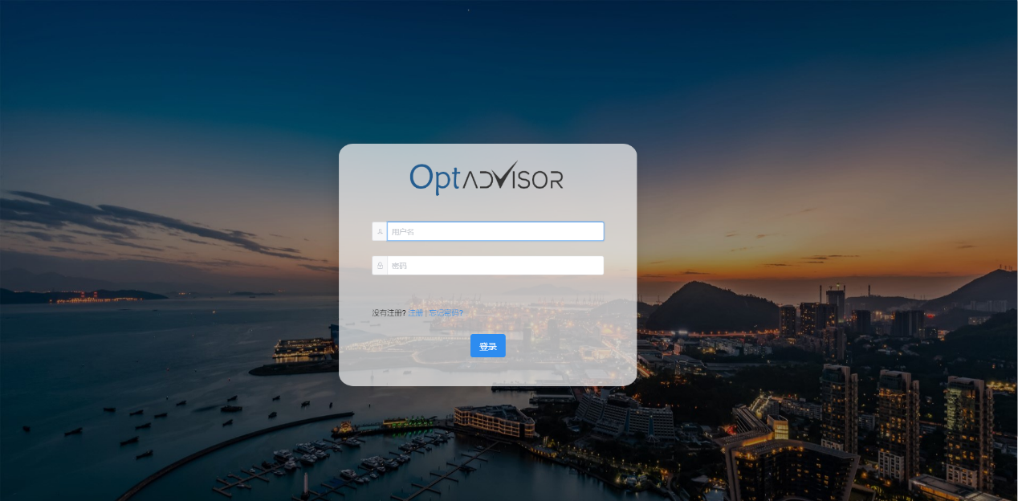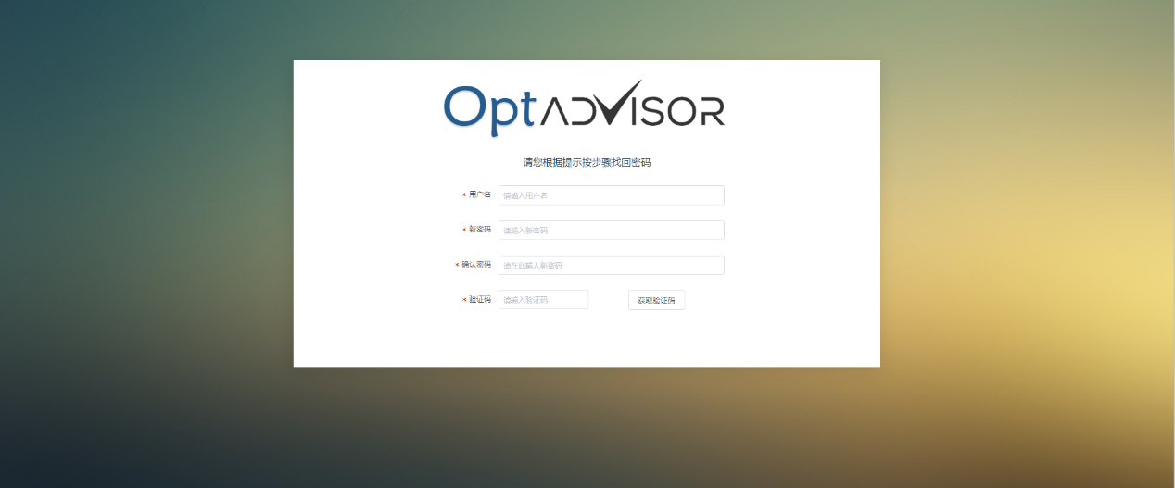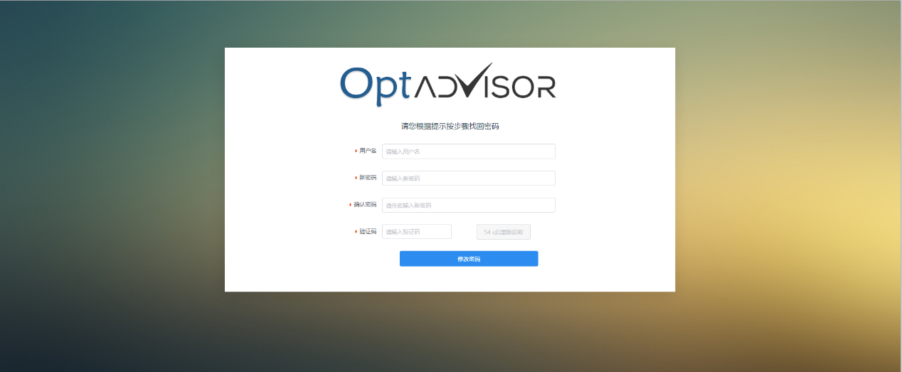

Users can change password according to the verification code they acquired.

4.1.4 Display 50ETF

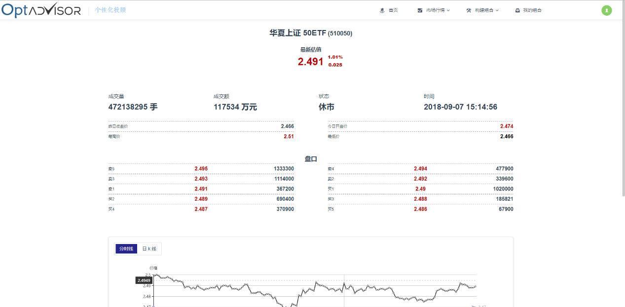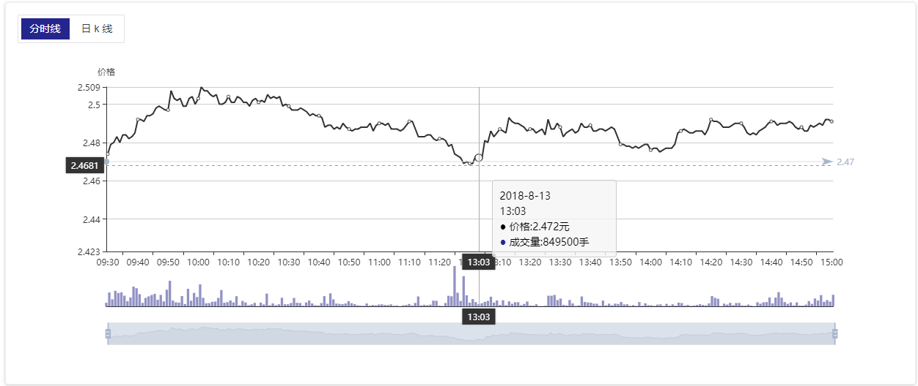

The market map have two versions, time-sharing line and K line, users can click related button to swap these two charts.

The chart are divided into three parts from the top to the bottom, they are price line chart, trading volume bar chart and chosen time.

Move the mouse to line chart or trading volume bar chart, users can check related market message.

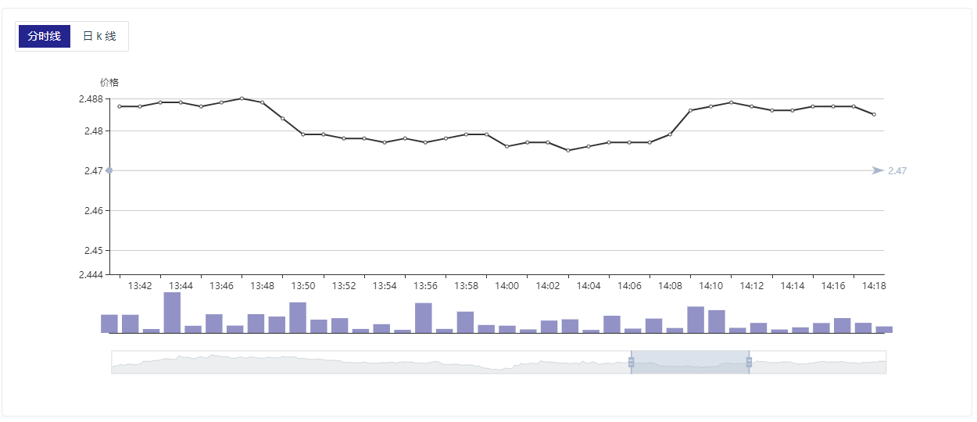The chart can be zoomed by scrolling the mouse on line part, trading volume part or chosen time part.

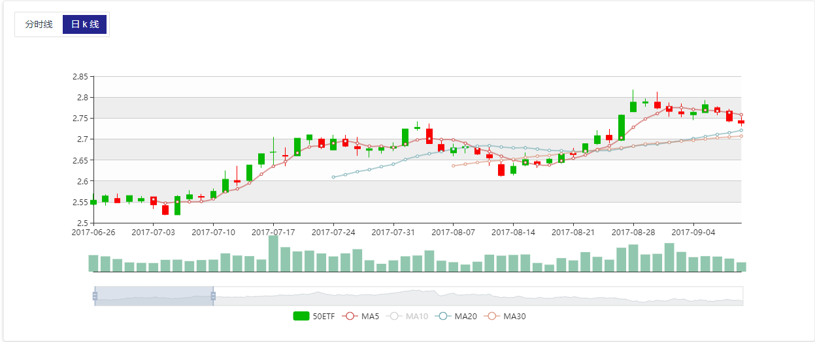

On the chosen time district, you can click the left mouse button and drag at the same time to change your observation time.

When using K line to display markets, click the picture below, you can hide or display related lines.

4.1.5 Allocation

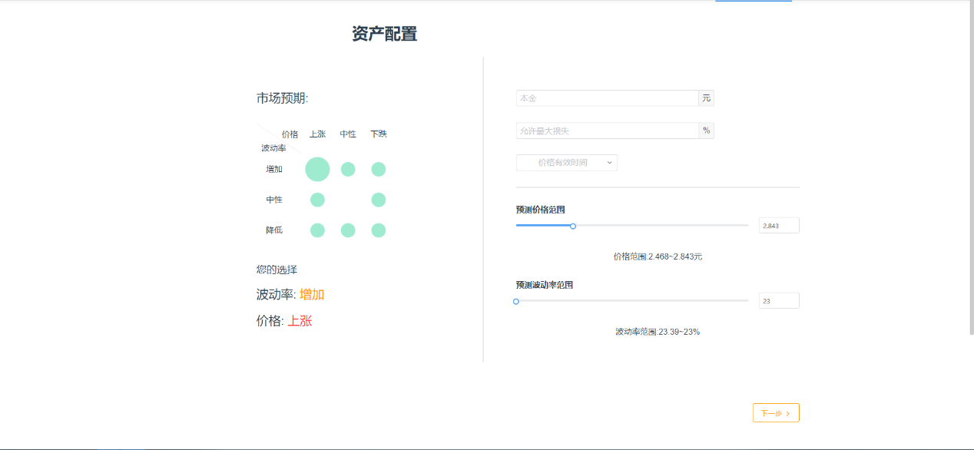

On the left part, market expectation offers 8 choices, users can click related circle according to 50ETF the expectation of price fluctuation ratio in the future personally, such as choosing (rise, increase) in this picture.

After choosing expectation preference, fill in principle, allowed maximum loss rate, valid price time on the right part and drag the sliding block or click any part of the progress bar to choose related expectation price and the expectation of fluctuation ration.

After selecting, click Next, wait for the calculation of the system and then view the recommend portfolio.

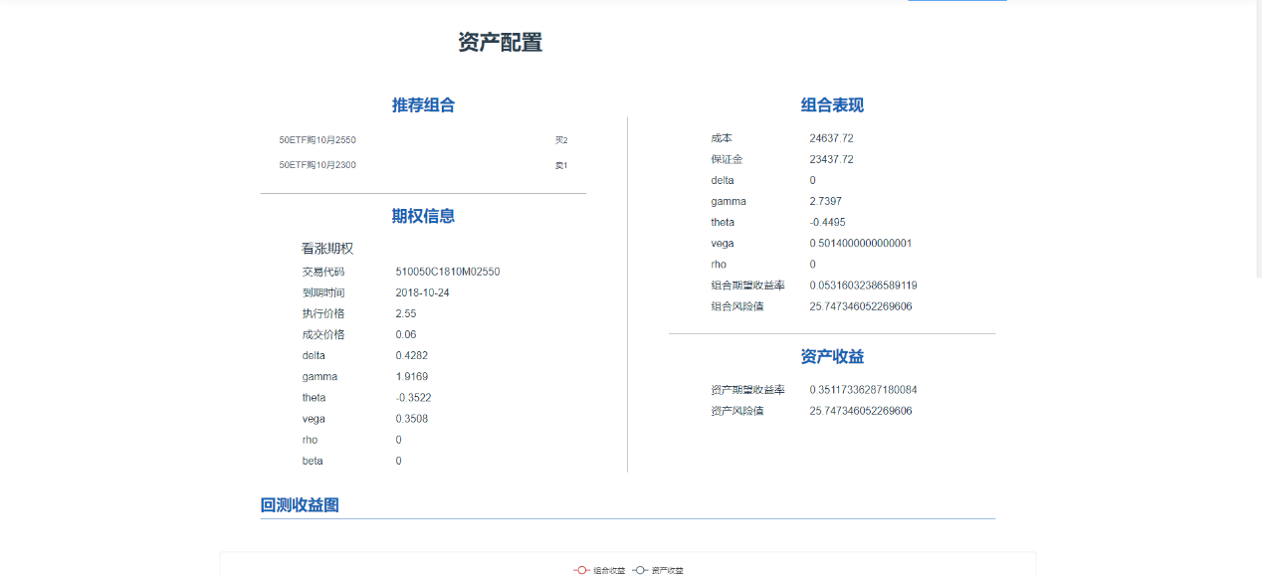

You can click Add to My Portfolio button on the right, type in portfolio name. Your portfolio is added to our database successfully, and the web page will skip to My Portfolio page.

4.1.6 Hedging

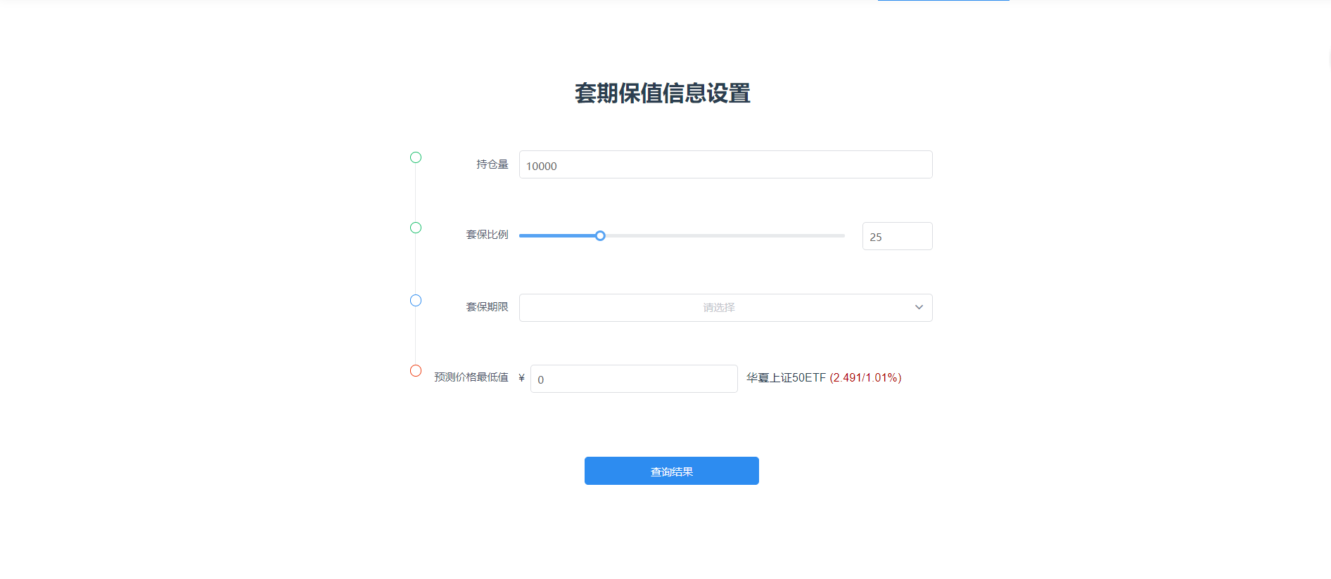

Fill in measuring bin, hedging rate and the lowest price of expectation, and then choose the hedging deadline, click search to skip to the hedging result page.

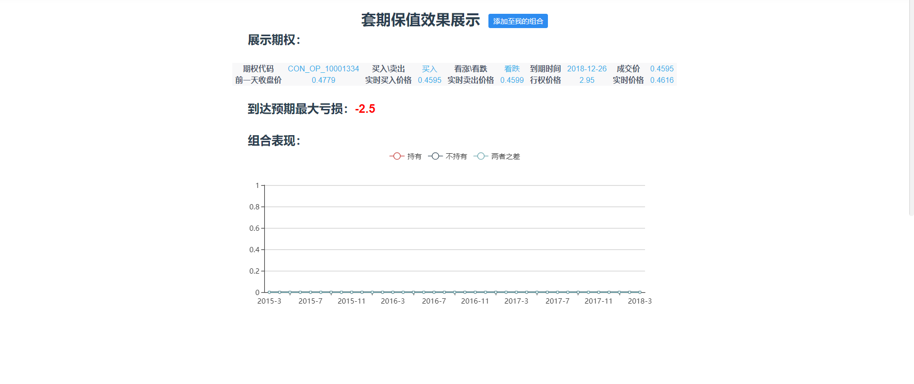

Click Add to My Portfolio button and type in the name, the portfolio is successfully added into database, and the page will skip to My Portfolio page.

4.1.7 DIY

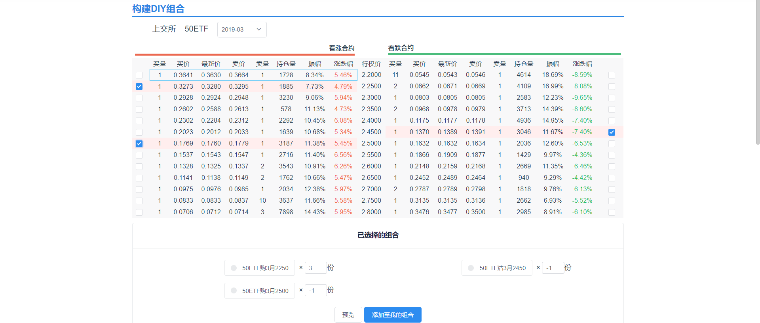

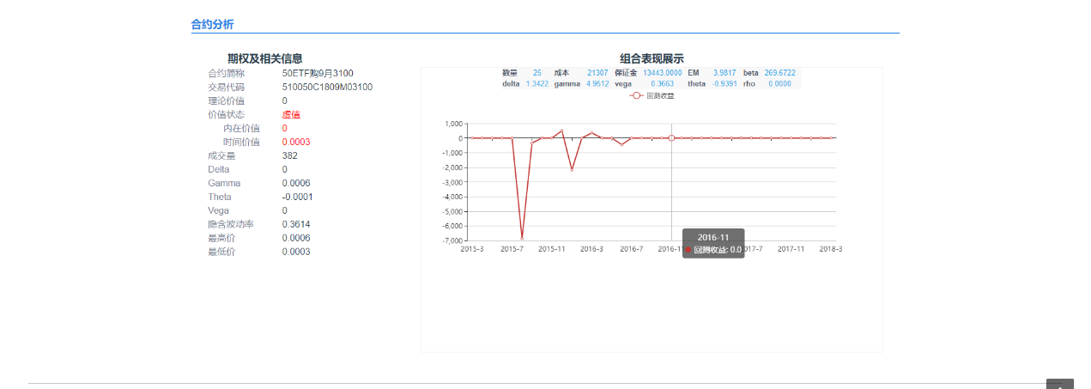

Select date first to view related option array.

Click options in this array, and then change option quantity in Chosen Portfolios below. The negative number means selling, on the contrary, the positive number means buying.

Users can click any option to view related option information in Option Analysis part below.

After choosing portfolio, click preview button to check the expression of selected options.

Click Add to My Portfolio button and fill in the portfolio name, users can successfully add the portfolio into database. And the page will skip to My Portfolio page.

4.1.8 My Portfolio

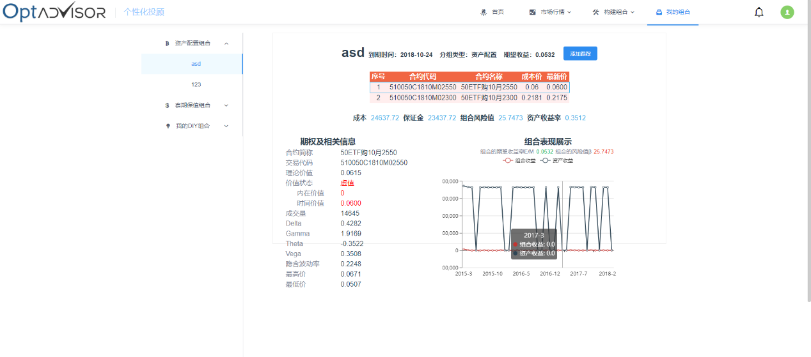

The left part are portfolios from different origins. Click the left button on the mouse to choose one portfolio, the right part will show specifications of the portfolio.

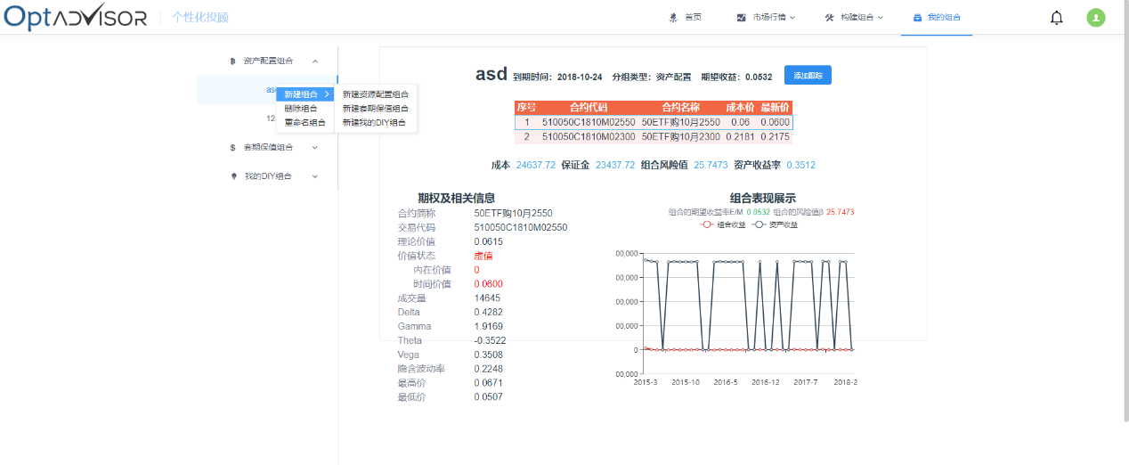

Click the right button on the mouse, users can manage the portfolios.

In the detailed portfolio page, click Track Portfolio button, users can track portfolio earning conditions continuously. The system will warn the user in Message page when the loss beyond the expectation.

4.1.9 Message Management

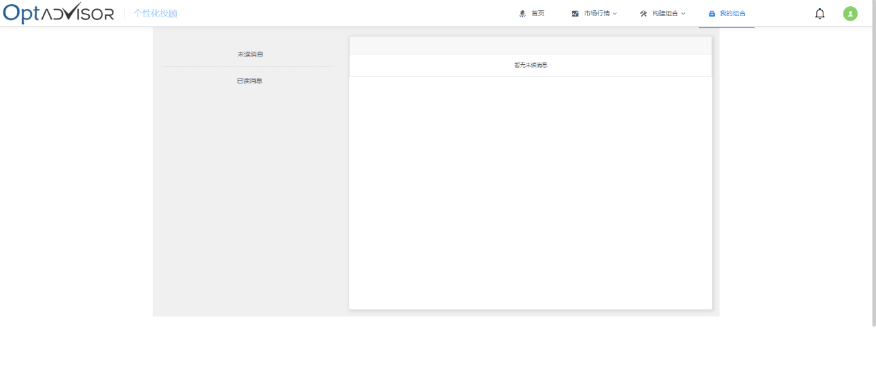

4.1.10 Personal Information

Click the aviator on the right-top, you can enter Personal Information page.

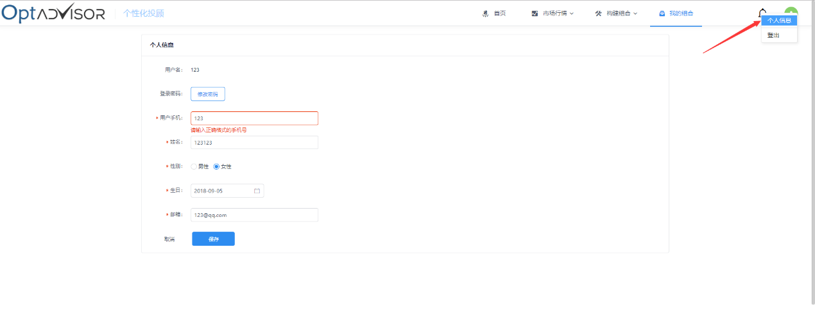

In Personal Information page, click Save button after change your information, your information will be updated.

Click Change Password button, fill in old password and new password according to the instructions and click the Save button, your password will be updated.